ORM Normative Abstract Syntax and Semantics: non-normative glossary

ORM.net Proposed Recommendation

Version: Public BETA 3 - 7 November 2025
Editors: Enrico Franconi, Terry Halpin

Contributors to DRAFT 4: Clifford Heath, Peter Norman

Abstract

Object-Role Modeling (ORM) is a rigorous approach to modeling and querying at the conceptual level the information semantics of arbitrary domains. This glossary document lists key terms and symbols used in ORM, and briefly explains their meaning by means of examples. It shows examples of the main graphical conceptual model constructs - namely declarations, constraints, and derivation rules - together with their corresponding abstract syntactic expressions, and their semantics specified as closed first-order logic formulas. This non-normative document makes use of the definitions specified in the normative document defining the abstract syntax and formal semantics of ORM conceptual models. The semantics of an ORM conceptual model is defined by transforming the model to first-order logic axioms, whose finite models denote the legal abstract information structures of the conceptual specification.

Status of this Document

This section describes the status of this document at the time of its publication. Other documents may supersede this document. A list of the revisions of this technical report can be found in the ORM.net Technical Recommendations index at <https://gitlab.com/orm-syntax-and-semantics/orm-syntax-and-semantics-docs.git>.

This document is part of the ORM document suite. It summarizes the abstract syntax of the main graphical symbols used in ORM by means of examples. The companion document “ORM Abstract Syntax and Semantics: normative specifications” formally defines the core ORM concepts. Both documents of the ORM document suite can be found at
<https://gitlab.com/orm-syntax-and-semantics/orm-syntax-and-semantics-docs.git>.

This document is published on ORM.net as a Proposed Recommendation. If you wish to make comments regarding this document, please send them to <orm-semantics@googlegroups.com>, after having registered at <https://groups.google.com/group/orm-semantics>. All comments are welcome.

Once this document becomes an ORM.net Recommendation, it will be a stable document and may be used as reference material or cited from other documents. ORM.net's role in making the Recommendation is to draw attention to the specification and to promote its widespread deployment. This enhances the functionality and interoperability of data models based on ORM or other fact-based modeling approaches.

Change History

- Public BETA 3: fixed typos.
- Draft 4: Adopted concrete syntax, fixed errors and formatting.

Construct and Examples | Normative Abstract Syntax of Examples | Normative Semantics of Examples
Signature: Entity type name  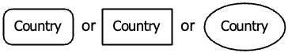 | Signature:  Entity Type name: Country  (The alternative graphical notations are equivalent, as preferred by different practitioners)
Signature: Entity type with reference mode  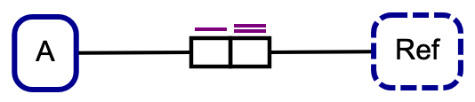  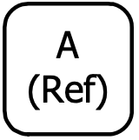 | Macro:
Signature: Value type name  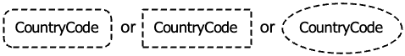 | Signature:  Value Type name: Country Code  (Case-sensitive. Spaces are allowed. Hyphenated words are allowed. The alternative graphical notations are equivalent, as preferred by different practitioners)
Signature: Value Syntax  This is not available in standard ORM. | Signature:  ValueSyntax(CountryCode /[A-Z][A-Z]/)  ValueSyntax(Population Natural)  ValueSyntax(Integer /0|[-+]?[1-9]\d*/)  ValueSyntax(Date /\d\d\d\d[-/]\d\d?[-/]\d\d?/)  (Instances of any Object type having a ValueSyntax may be identified by a value matching that syntax) | ValueSyntax is a macro for defining sets of values.  Syntax is defined by matching a Regular Expression or the syntax belonging to another ObjectType which has a (well-founded) syntax.  Natural, Integer, Real, String, Date, Time and RegularExpression may be predefined.
Signature: Predicate name  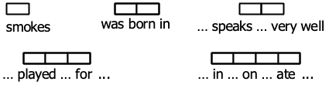  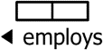 | Signature:  Unary predicate reading: smokes, ? has cancer  Unary predicate name: Person smokes, Person has cancer  Binary predicate readings: was born in,  ? speaks ? very well  reports to, employs  Ternary predicate readings: ? played ? for ?  Quaternary predicate reading: ? in ? on ? ate ?  Hyphen-bound text: green- Frog has Pigment  Grenouille -verte à Pigment  ? drives semi-- trailer ?  ? conduit ? semi --remorque  Predicate names may be formed any way as long as the usage is consistent and the names are unique in the schema. These examples show predicate readings, which are expanded into predicate names by the inclusion of the names of object types which play the roles. ORM is a typed logic, so predicates are typed by the types of the role players. The hyphen-bound examples show the formation of default role names. | Predicate symbols:  personSmokes, personHasCancer  personWasBornInCity,  personSpeaksLanguageVeryWell,  personReportsToPerson, personEmploysPerson  personPlayedSportForCountry  greenFrogHasPigment.greenFrog uses a default role name.  grenouilleVertÀPigment.grenouilleVerte uses a default role name.  PersonDrivesSemi-Trailer  The normative semantics requires unique predicate symbols. These examples concatenate the words of the canonical predicate name name with the object type names in camelCase, without the question marks, whitespace or hyphen-bound text, but any other means of deriving predicate symbols is valid as long as they are stable and distinct. Later examples do not follow this pattern.
Signature: Alternative predicate name  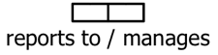 | Alternative predicate name:  AlternativePredicate(reports to,  manages (reports to.2, reports to.1))  Since the source predicate is known, FIG concrete syntax also allows:  AlternativePredicate(reports to, manages(.2, .1))
Signature: Role name  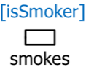  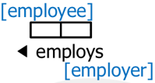 | Role names:  RoleNaming(smokes.1, isSmoker)  RoleNaming(employs.1, employer)  RoleNaming(employs.2, employee)  RoleNaming(drives.1, driver)  Signature:  Role identifier for the unary predicate smokes:  smokes.1  Role identifiers for the binary predicate employs:  employs.1, employs.employee | In the concrete syntax, default role names (where no explicit role name is provided) are derived from a unique domain object type name, potentially including hyphen-bound text.
Unary fact type  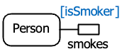 | FactType(smokes (Person))  RoleNaming(smokes.1, isSmoker)
Binary fact type  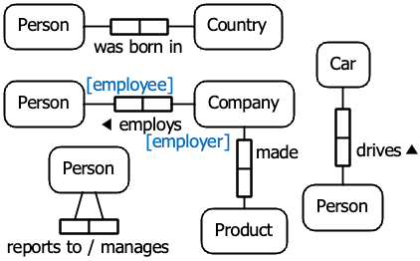 | FactType(was born in (Person, Country))  FactType(employs (Company, Person))  (RoleNaming as above)  FactType(made (Company, Product))  FactType(? drives ? (Person, Car))  FactType(reportsTo (Person, Person))
Ternary fact type  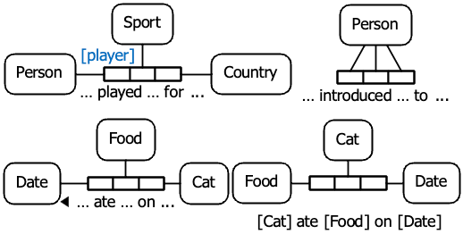 | FactType(?played?for?  (Person, Sport, Country))  RoleNaming(?played?for?.1, player)  FactType(? introduced ? to ?  (Person, Person, Person))  FactType(?ate?on? (Cat, Food, Date))  (note the use of the reading-direction arrow and role player names)
Quaternary fact type  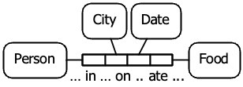 | FactType(?in?on?ate? (Person, City, Date, Food))
Objectification  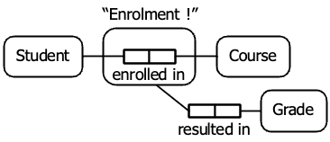  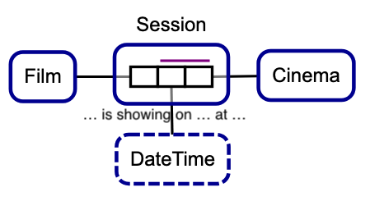 | FactType(enrolledIn (Student, Course))  Objectifies(Enrolment, enrolledIn)  FactType(resultedIn (Enrolment, Grade))  FactType(?is showing on ? at?  (Film, DateTime, Cinema))  Objectifies(Session, ?is showing on ? At?)  Note: the objectification function for this predicate ignores Film, so only Cinema and DateTime identify the Showing
Uniqueness constraints on binary fact types  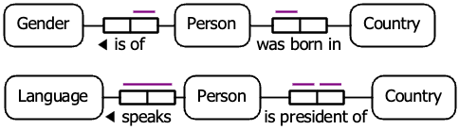 | Unique(isOf.1)  Unique(wasBornIn.1)  Unique(speaks.1, speaks.2)  Unique(isPresidentOf.1)  Unique(isPresidentOf.2)
Uniqueness constraints on ternaries  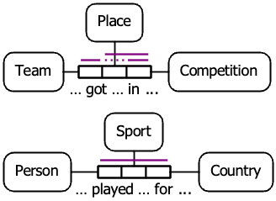 | Unique(?got?in?.1, ?got?in?.3)  RoleNaming(?got?in?.2, placing)  Unique(?got?in?.placing, ?got?in?.3)  Unique(?played?for?.1, ?played?for?.2,  ?played?for?.3)  Note: This uniqueness constraint is tautological. ORM tools will normally show it anyway.
Simple mandatory role constraint  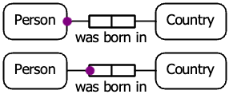 | Mandatory(Person, wasBornIn.1)  (note: choice of location for the role dot is personal preference)
Inclusive-or constraint  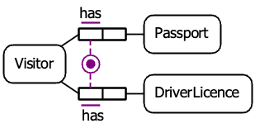 | Mandatory(Visitor,  hasPassport.1, hasDriverLicence.1)
Single-role identification  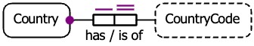 | SimpleIdentification(Country, has.1, has.2)  (note: the use of forward/reverse reading text)  (note: the doubled-line uniqueness indicates preferred identifier. This preference does not affect the semantics and is not formalised) | well-founded(has)
External uniqueness constraint and identification  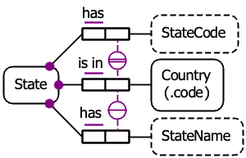 | ExternalIdentification(State  (hasStateCode.2, isIn.2))  ExternalUnique(hasStateName.2, isIn.2) | ExternalIdentification creates new predicate P with arity 3.  well-founded(hasStateCode ∪ isIn)  ExternalUnique creates new predicate Q with arity 3.
Object type value constraint  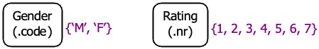  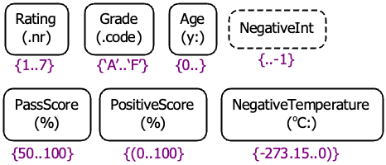  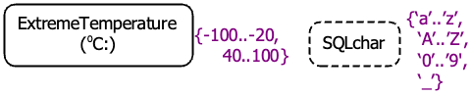 | ValuesOf(GenderCode (‘M’, ‘F’))  ValuesOf(SQLchar (‘a’..’z’, ‘A’..’Z’,  ‘0’..’9’, ‘_’))  Note: Values conform to the appropriate ValueSyntax.
Role value constraint  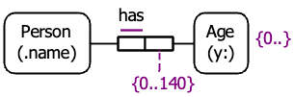 | ValuesOf(has.2 (0, 1, 2, .. 140))  ValuesOf(has.2 (0 .. 140))
Subset constraint  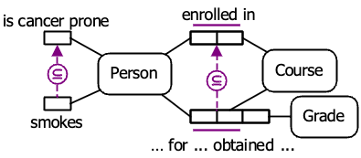 | Subset((smokes.1, isCancerProne.1))  Subset((?for?obtained?.1, enrolledIn.1)  (?for?obtained?.2, enrolledIn.2))
Join subset constraint  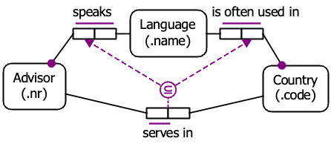 | JoinPath(P (speaks.1, speaks.2)  (isOftenUsedIn.1, isOftenUsedIn.2))  Subset((servesIn.1, P.1)(servesIn.2, P.2))
Exclusion constraint  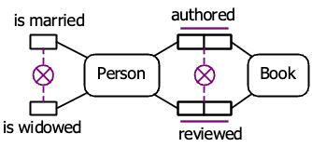 | Exclusive((isWidowed.1, isMarried.1))  Exclusive((reviewed.1, authored.1)  (reviewed.2, authored.2))
Equality constraint  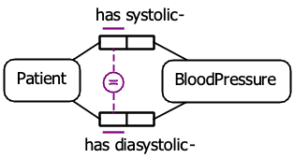 | Equal((has systolic-.1, has diasystolic-.1))  Note: the concrete syntax allows more than two roles in each group, as a convenience macro.
Subtyping  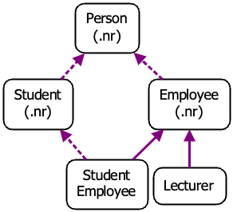 | Subtype(Lecturer, Employee)  Subtype(Employee, Person)  Subtype(Student, Person)  Subtype(StudentEmployee, Student)  Subtype(StudentEmployee, Employee)  Note: the dotted line subtype indicates that preferred identification is not inherited. This preference is not relevant to the formalisation.
Subtyping constraints  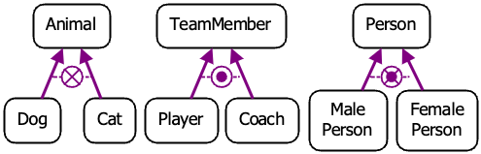 | ExclusiveSubtypes((Dog, Cat) Animal)  ExhaustiveSubtypes((Player, Coach) TeamMember)  ExclusiveSubtypes((MalePerson, FemalePerson)  Person)  ExhaustiveSubtypes((MalePerson, FemalePerson)  Person)
Internal frequency constraint  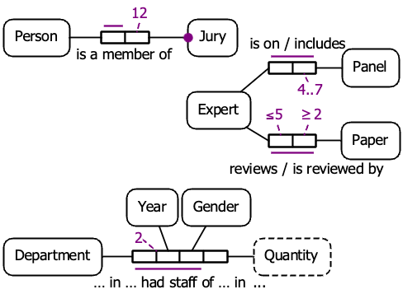 | Frequency(12, isAMemberOf.2)  Frequency((4, 6), hasWheels.2)  Frequency(4..7, isOn.2)  Frequency(..5, reviews.1)  Frequency(2.., reviews.2)  Frequency(2, ?in?hadStaffOf?in?.1,  ?in?hadStaffOf?in?.2)
External frequency constraint  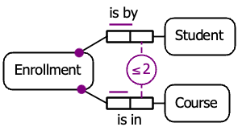 | ExternalFrequency(..2, isBy.2, isIn.2) | ExternalFrequency creates a new predicate P of arity 3
Value-comparison constraint  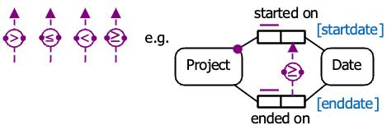 | ≥(endedOn.2, startedOn.2) | Given new predicate name P:
Object cardinality constraint  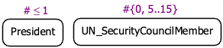 | TypeCardinality(President (0 .. 1))  TypeCardinality(UN_SecurityCouncilMember  (0, 5 .. 15))
Role cardinality constraint  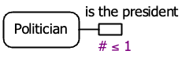 | RoleCardinality(isThePresidentOf (0 .. 1))
Ring constraints  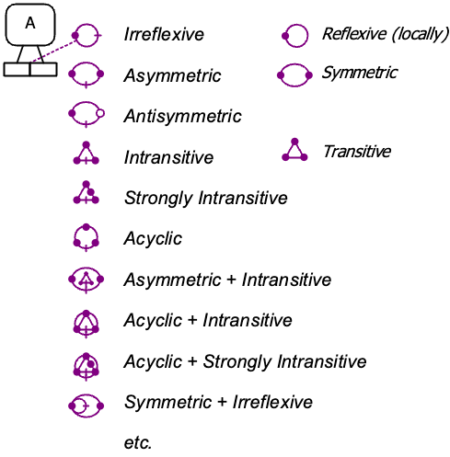 | LocallyReflexive(P.1, P.2)  etc. | etc.

Derivation Rules  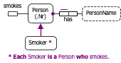 | SubTypeRule(Smoker, Person ∧ smokes)
SubTypeSemiRule(Taxpayer, Person∧pays taxes)
SubTypeSemiRule(Taxpayer, Company∧pays taxes)

Note: semi-derivation uses directional implication which means there may exist Taxpayers who do not actually pay taxes.
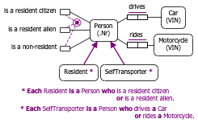 | SubTypeRule(Resident,  (Person ∧  (isAResidentCitizen ∨ isAResidentAlien)))  SubTypeRule(SelfTransporter,  (Person ∧  ((drives.1 ➤ [drives.2 ⋈ Car]) ∨  (rides.1 ➤ [rides.2 ⋈ Motorcycle]))))  Note: SelfTransporter is typed as a Person, and the predicates drives and rides are both typed, so this example may be written more succinctly as merely:  SubTypeRule(SelfTransporter, drives.1 ∨ rides.1)  This principle applies throughout these examples.
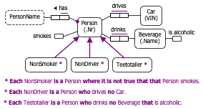 | SubTypeRule(NonSmoker, (Person ∖ smokes))  SubTypeRule(NonDriver,  (Person ∖ (drives.1 ➤ [drives.2 ⋈ Car])))  SubTypeRule(TeeTotaller,  (Person ∖  (drinks.1 ➤ [drinks.2 ⋈  (Beverage ∧ isAlcoholic)])))
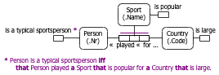 | FactTypeRule(isATypicalSportsPerson,  (Person ∧ ?played?for?.1 ➤  [?played?for?.2 ⋈ (Sport ∧ isPopular)]  [?played?for?.3 ⋈ (Country ∧ isLarge)]))
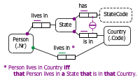 | FactTypeRule(livesInCountry,  (Person ∧ livesInState.1 ➤  [livesInState.2 ⋈ (State ∧ isIn.1 ➤  [isIn.2 ⋈ (Country ∧ ?x)])]),  (Country ∧ ?x))
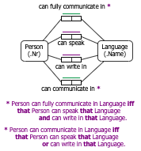 | FactTypeRule(canFullyCommunicateIn,  (Person  ∧ (canSpeak.1 ➤ [canSpeak.2 ⋈ (Language ∧ ?x)])  ∧ (canWrite.1 ➤ [canwrite.2 ⋈ (Language ∧ ?x)])  ),  (Language ∧ ?x)  )  FactTypeRule(canCommunicateIn,  (Person  ∧ ((canSpeak.1 ➤ [canSpeak.2 ⋈ (Language ∧ ?x)])  ∨ (canWrite.1 ➤ [canwrite.2 ⋈ (Language ∧ ?x)])  )  ),  (Language ∧ ?x)  )
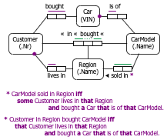 | FactTypeRule(soldIn,  (CarModel ∧ ?x),  (Region ∧  (livesIn.2 ➤ [livesIn.1 ⋈ Customer ∧  (bought.1 ➤ [bought.2 ⋈ Car ∧  (isOf.1 ➤ [isOf.2 ⋈ (CarModel ∧ ?x)])])])))  FactTypeRule(?in?bought?,  (Customer ∧  (livesIn.1 ➤ [livesIn.2 ⋈ (Region ∧ ?x)]) ∧  (bought.1 ➤ [bought.2 ⋈ (Car ∧  (isOf.1 ➤ [isOf.2 ⋈ CarModel ∧ ?y]))])),  (Region ∧ ?x),  (CarModel ∧ ?y))

